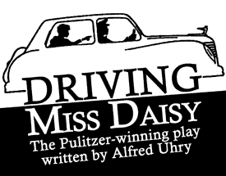

Protest Music Project
TASK:
- Research protest music of the Civil Rights Movement.
- Choose a song and present it to the class.
ASSIGNMENT:
- Create a PowerPoint Presentation in which you:
  - Provide an explanation of who the artist is and how and why he/she was important during the Civil Rights Movement.
  - Play the song for your audience.
  - Discuss why the lyrics of this song are significant and represent the feeling of the Civil Rights Movement.

