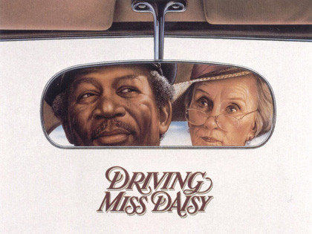

- Introduction: Bring in an author biography (Alfred Uhry) from a credible web source.
- Pages 4 – 8: Bring in one picture that represents the South from 1950 – 1970. Include a three sentence explanation of why the picture is important.
- Pages 8 – 12: What is the main problem? How does this affect all three characters? Include page numbers in your answers.
- Pages 13 – 17: How does each character deal with the main problem? Include page numbers in your answers.
- Pages 17 – 31: Draw a picture or print out a picture from the Internet of something important from the play. Include a three sentence explanation of why the picture is important.
- Pages 31 – 39: Choose three quotes that are significant. Include the page number and explanation.

