Name Date
Per “The Last Leaf”
Thinking It Through
- At the end of the story, Sue calls the leaf “Behrman’s masterpiece.” What does she mean?
________________________________________________________________________________________________________________________________________________________________________________________________________________________

- If you were Johnsy, what would be your feelings at the end?
________________________________________________________________________________________________________________________________________________

- Although the last paragraph comes as a surprise to most readers, it at least seems like a possible ending to the story. This is due to O. Henry’s careful foreshadowing. List two things the reader is told about Behrman that help foreshadow the ending.
________________________________________________________________________________________________________________________________________________

- “The Last Leaf” deals with not one but several BIG IDEAS about life. In your opinion, what is one important theme in the story? Why? These words may guide your thinking: love, faith, courage
________________________________________________________________________________________________________________________________________________________________________________________________________________________
________________________________________________________________________

- As you know, the technique of giving human qualities to non human subjects is known as personification. For example, people may speak of Mother Nature and Father Time. How does O. Henry use personification on page 1 of the story?
________________________________________________________________________________________________________________________________________________________________________________________________________________________

- We said in class that O. Henry’s name is synonymous (means the same as) irony. What is ironic in this story?
________________________________________________________________________________________________________________________________________________________________________________________________________________________

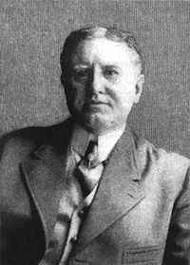
William Sydney Porter (a.k.a O. Henry)

